MAINTAINCE SHEET FOR GC-NET v3
Station name: | DY2 |  | Date: | 30-04-2026
People present: | RSF, RABNI, IASTE, ARU, HETJA, ASNOR |  | Maintenance |  | Install | Take-down | Data Download

Weather: | Sunny, high clouds

METADATA
 | Arrival | Departure
Download Data | YES / NO | NA
Time difference between logger and UTC (± mm:ss) | 00:12 | 00:00
Screenshot of ‘Status’ table | YES / NO | YES / NO
Screenshot of ‘Public’ table in FastScan mode | YES / NO | YES / NO
Photos of mast, loggerbox and sensors (inc. radiometer serial) | YES / NO | YES / NO

STATION POSITON AND OREINTATION
 |  |  | Arrival |  | Departure
Lower lufft height (see A) |  |  | 310 cm |  | 310 cm
Lower SR50 height (see A) |  |  | 280 cm |  | 280 cm
Upper lufft height (see A) |  |  | 425 cm |  | 425 cm
Upper SR50 height (see A) |  |  | 405 cm |  | 405 cm
Upper boom direction (towards radiometer, see B) |  |  | 340 degree mag. |  | 340 degree mag.
Lower boom direction (towards lufft, see B) |  |  | 250 degree mag. |  | 250 degree mag.
Upper wind sensor orientation (away from black box, see C) |  |  | Yes |  | Yes
Lower wind sensor orientation (away from black box, see C) |  |  | Yes |  | Yes
Radiometer across-boom tilt, looking at the front (see D) |  |  | 3 degree to left/west |  | Same
Mast tilt north-south axis |  |  | 4 degree down-north |  | Same
Mast tilt east-west axis |  |  | 5 degree to right/east |  | Same
Height of thermistor string pipe above surface |  |  | NA |  | ? cm
Depth of snowboard | 68 cm | Height of snowboard stake |  | 85 cm Vertical: YES / NO
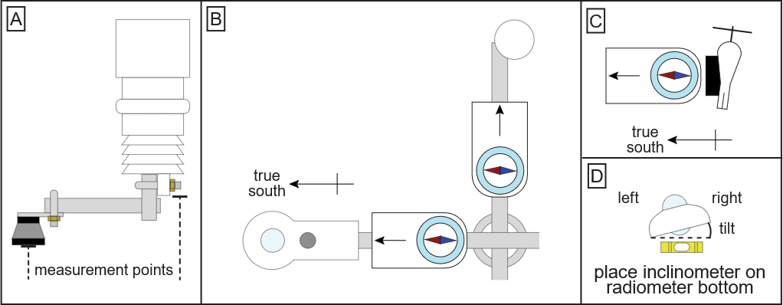

Station name: | DY2 |  | Date: | 30-04-2026
STATION HARDWARE
To do? | Done? | Item | Comments
Update program | yes | Loggerbox | ID arrival: None  ID departure: None
Replace | Yes | Modem IMEI | IMEI arrival: 300534063811780  IMEI departure: 300234010884770
Replace | Yes | Radiometer | Serial arrival: 131455  Serial departure: 212890
 |  | Wind sensor upper | Type arrival: Black / White  Type departure: Black / White
 |  | Wind sensor lower | Type arrival: Black / White  Type departure: Black / White
Replace | Yes | Lufft upper
Replace | Yes | Lufft lower
Replace | Yes | SR50 upper
Replace | Yes | SR50 lower
Extend |  | Thermistor string
 |  | Iridium antenna
 |  | Solar panel
Replace | Yes | Battery box | Burial under lower lufft: YES / NO  Location if NO:
Extend | No | Mast | Unable to lift mast. Extension was unnecessary.

NOTES (e.g. sensor damage, must-do at next visit)
Newest logger OS installed: OS 8.5.1
New snowboard top 145 cm
No liquid GNSS installed

